MEDIA COVERAGE REPORT



SLCM wins FICCI sustainable Agriculture Awards 2021

INDEX
SLCM wins FICCI sustainable Agriculture Awards 2021
S.No. | Date | Publication | Edition | Headline
1 | 22-Nov-2021 | APN News | Online | SLCM honoured with the prestigious FICCI Sustainable Agriculture Awards 2021
2 | 22-Nov-2021 | Financial Samachar | Online | SLCM honoured with the prestigious FICCI Sustainable Agriculture Awards 2021
3 | 22-Nov-2021 | Agriculture Post | Online | SLCM bags FICCI Sustainable Agriculture Award 2021
4 | 22-Nov-2021 | India Education Diary | Online | SLCM honoured With The Prestigious FICCI Sustainable Agriculture Awards 2021
5 | 22-Nov-2021 | India News Republic | Online | SLCM received the prestigious FICCI Sustainable Agriculture Awards 2021
6 | 22-Nov-2021 | India Today Post | Online | SLCM honoured with the prestigious FICCI Sustainable Agriculture Awards 2021
7 | 22-Nov-2021 | Krishi Jagran | Online | SLCM honoured with Prestigious FICCI Sustainable Agriculture Awards 2021
8 | 22-Nov-2021 | Agro Spectrum India | Online | SLCM bags FICCI Sustainable Agriculture Awards 2021
9 | 22-Nov-2021 | Cityairnews | Online | SLCM honoured with Prestigious FICCI Sustainable Agriculture Awards 2021
10 | 22-Nov-2021 | Konexionetwork | Online | SLCM honoured with the prestigious FICCI Sustainable Agriculture Awards 2021
11 | 22-Nov-2021 | Indifoodbev | Online | SLCM wins FICCI sustainable Agriculture Awards 2021
12 | 22-Nov-2021 | SDGTalks | Online | SLCM honoured with the prestigious FICCI Sustainable Agriculture Awards 2021
13 | 23-Nov-2021 | Janpath Samachar | Print | SLCM honoured with the prestigious FICCI Award 2021

Publication | Agriculture Post | Date | 22-November-2021
Link | https://agriculturepost.com/slcm-bags-ficci-sustainable-agriculture-award-2021/

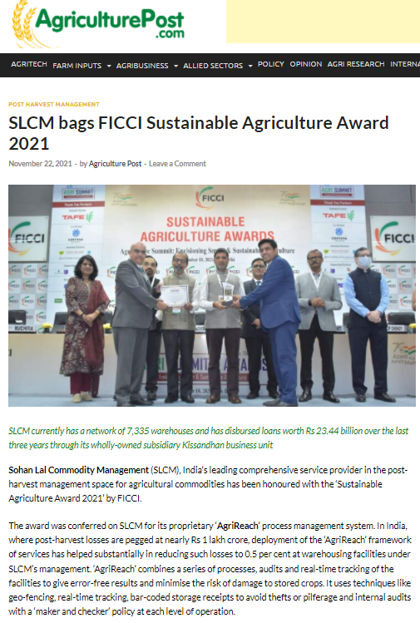

Publication | Krishi Jagran | Date | 22-November-2021
Link | https://krishijagran.com/industry-news/slcm-honoured-with-prestigious-ficci-sustainable-agriculture-awards-2021/

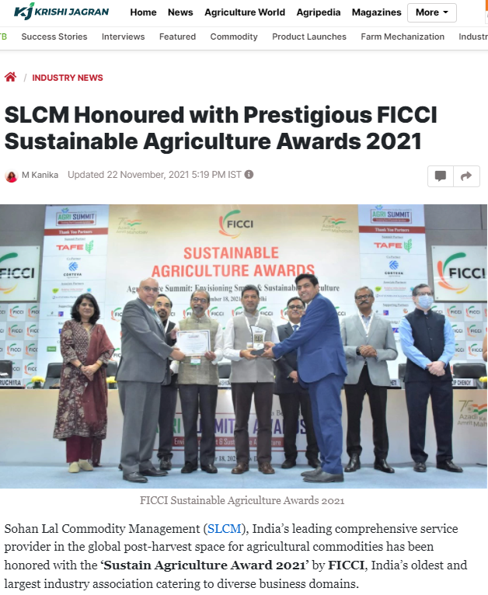

Publication | Agro Spectrum India | Date | 22-November-2021
Link | http://www.agrospectrumindia.com/news/105/3662/slcm-bags-ficci-sustainable-agriculture-awards-2021.html

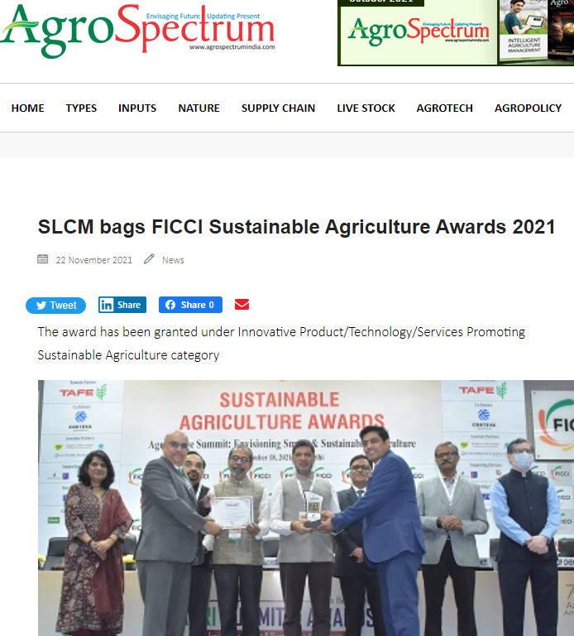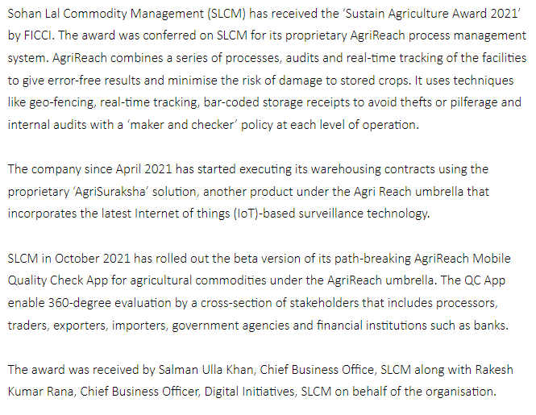

Publication | Indifoodbev | Date | 22-November-2021
Link | https://indifoodbev.com/agriculture/slcm-wins-ficci-awards-2021/

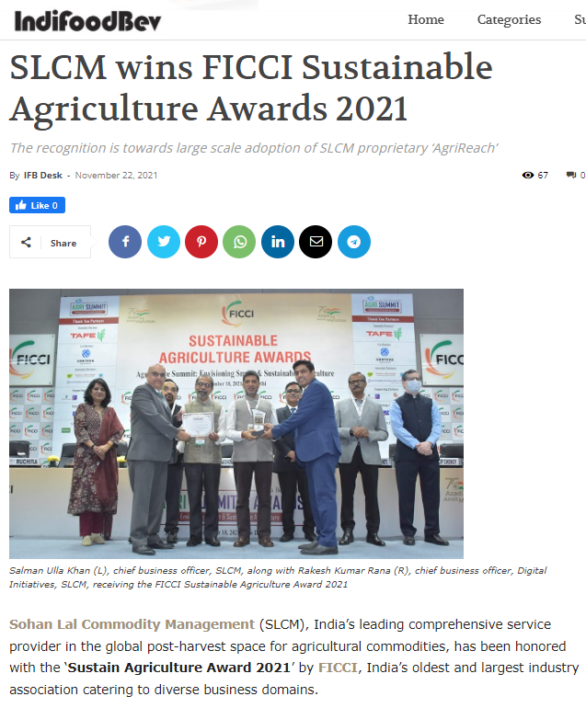

Publication | APN News | Date | 22-November-2021
Link | https://www.apnnews.com/slcm-honoured-with-the-prestigious-ficci-sustainable-agriculture-awards-2021/

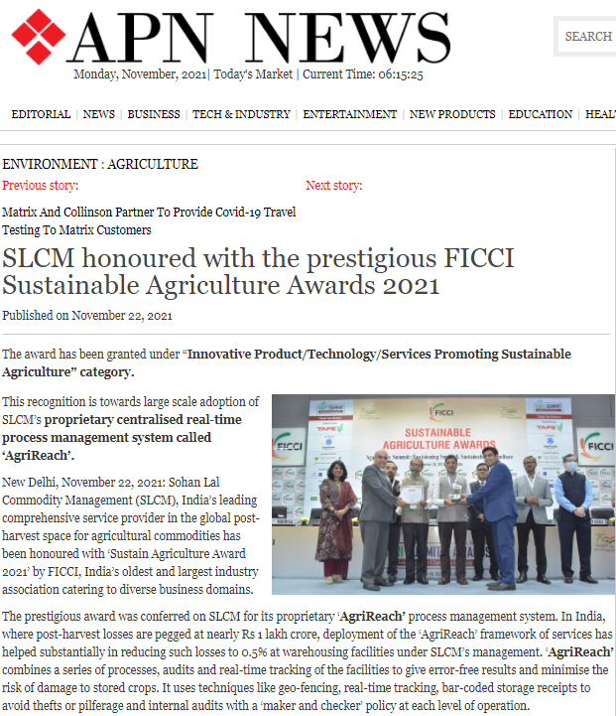

Publication | Financial Samachar | Date | 22-November-2021
Link | https://financialsamachar.com/slcm-honoured-with-the-prestigious-ficci-sustainable-agriculture-awards-2021/

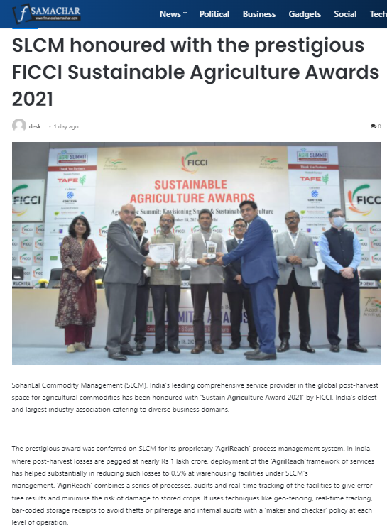

Publication | India Education Diary | Date | 22-November-2021
Link | https://indiaeducationdiary.in/slcm-honoured-with-the-prestigious-ficci-sustainable-agriculture-awards-2021/

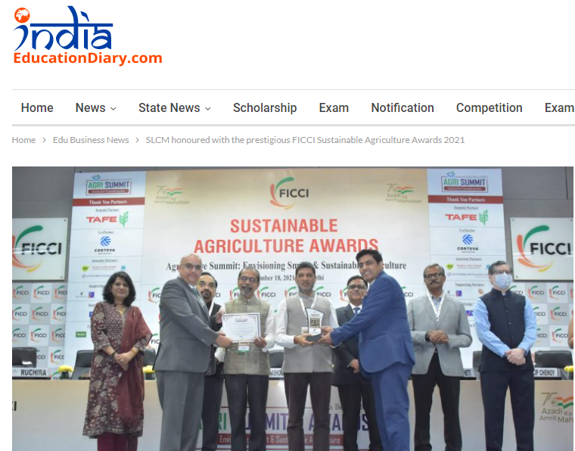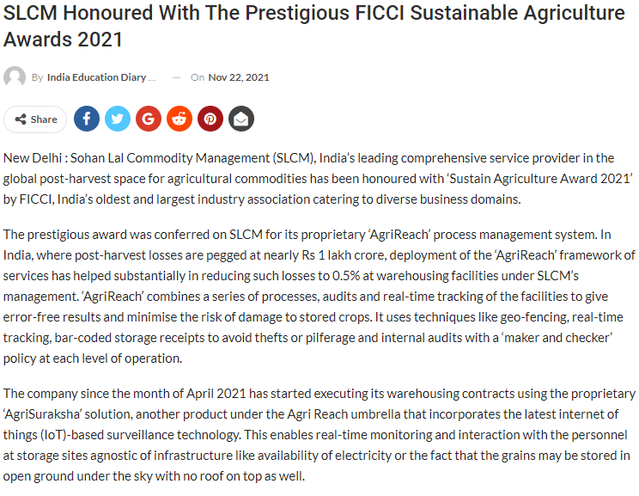

Publication | India News Republic | Date | 22-November-2021
Link | https://indianewsrepublic.com/slcm-received-the-prestigious-ficci-sustainable-agriculture-awards-2021-india-education-latest-education-news-global-education-news/552865/

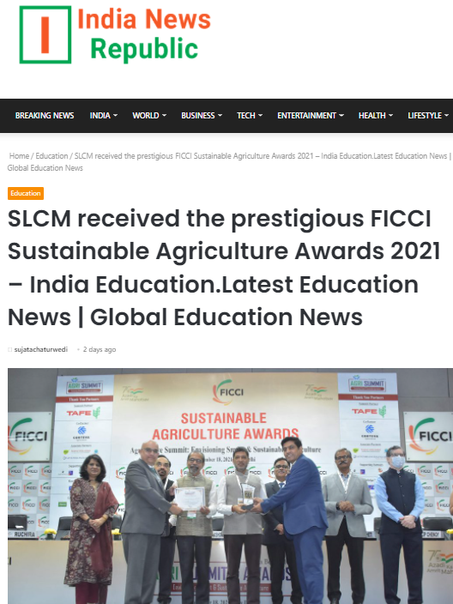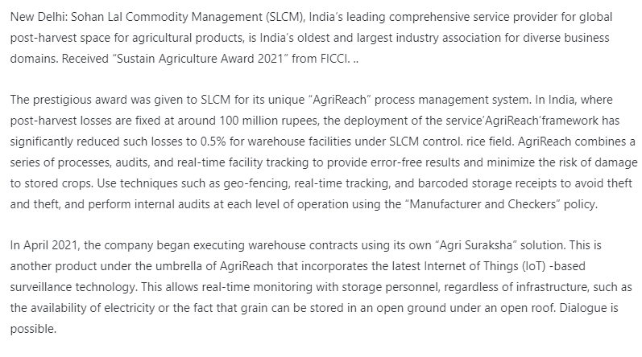

Publication | India Today Post | Date | 22-November-2021
Link | https://indiatodaypost.com/slcm-honoured-with-the-prestigious-ficci-sustainable-agriculture-awards-2021/

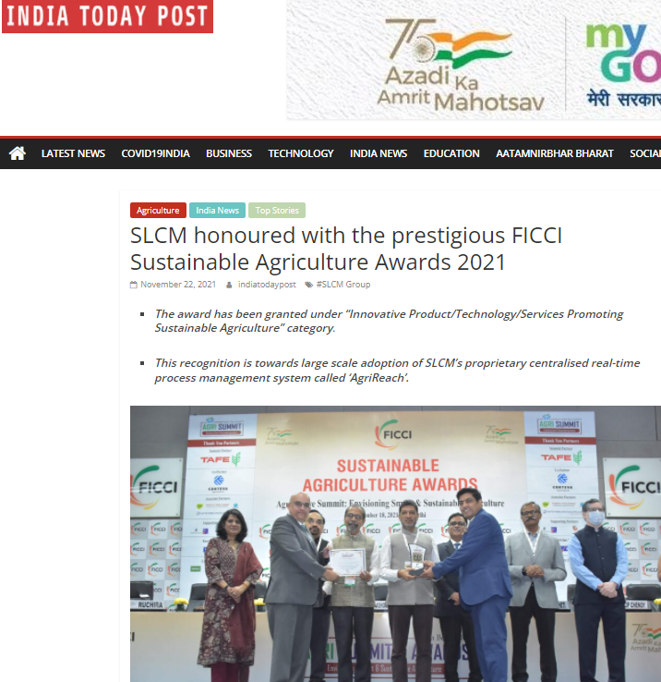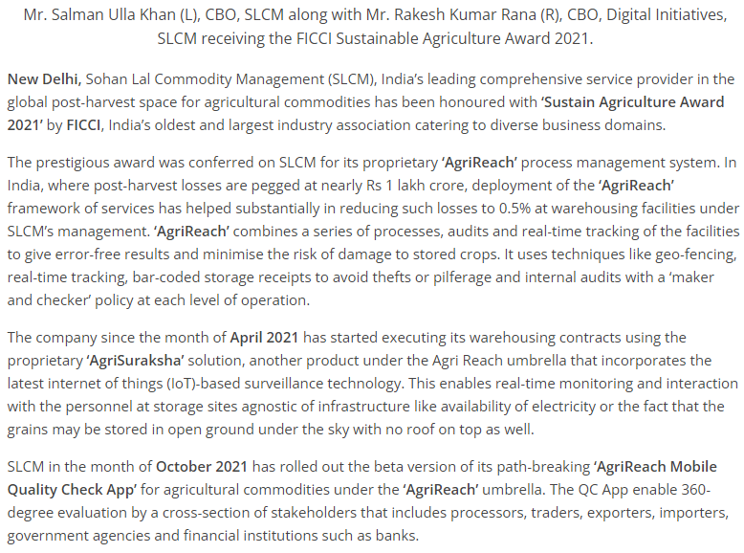

Publication | Cityairnews | Date | 22-November-2021
Link | https://www.cityairnews.com/content/slcm-honoured-with-prestigious-ficci-sustainable-agriculture-awards-2021

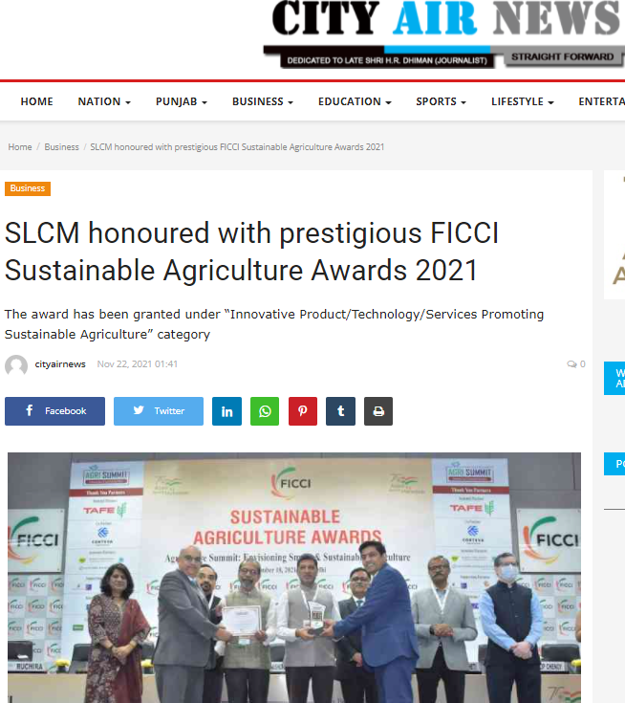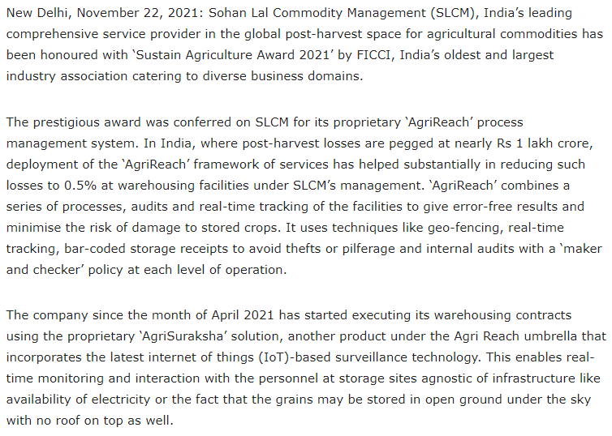

Publication | Konexionetwork | Date | 22-November-2021
Link | https://konexionetwork.com/NewsDetails.aspx?newsid=5d420aae-935f-44f5-b4de-652036039de1

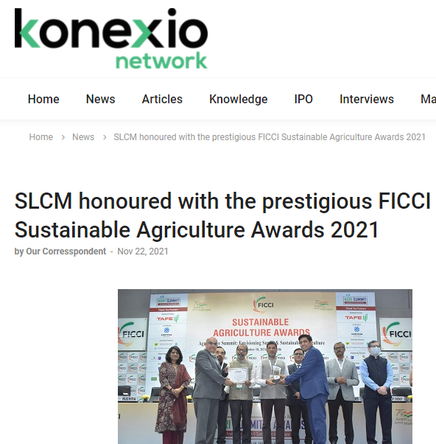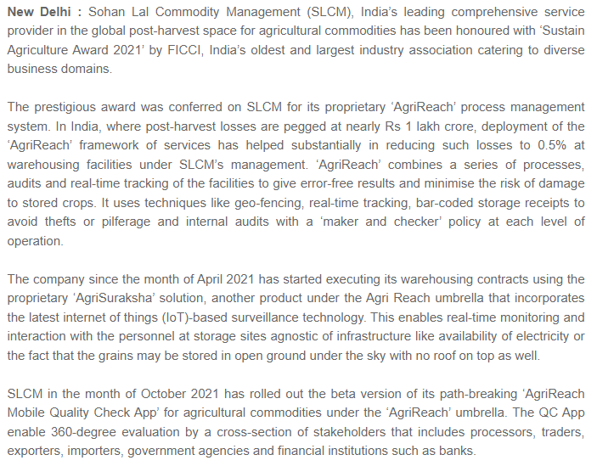

Publication | SDG Talks | Date | 22-November-2021
Link | https://sdgtalks.ai/slcm-honoured-with-the-prestigious-ficci-sustainable-agriculture-awards-2021-apn-news

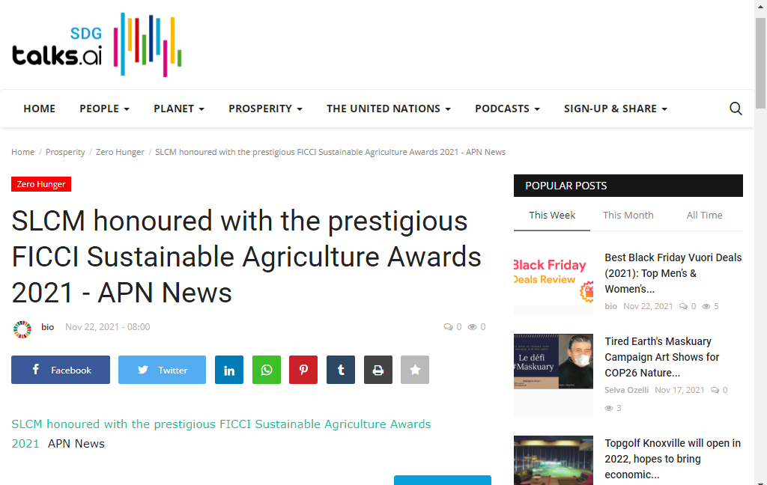

Publication | Janpath Samachar | Date | 23-November-2021
Edition | Mumbai & Siliguri

